**Capstone Project Title**

Thesis submitted in partial fulfillment of the

requirements for the

**Post Graduate Certificate Program in**

**Data Science and Machine Learning**

By

**Abhilash Pethota**

**Bharath Bhushan BR**

**M Rajendra Prasad**

**Suraj P**

**Vinutha A**

Under the guidance of

Mayukh Ghosh



Acknowledgments

We would like to express our sincere gratitude to all those who have supported us during the course of this project.

First and foremost, we would like to thank our mentor, Mayukh Ghosh for his continuous guidance, valuable insights, and constant encouragement throughout this project. His expertise and constructive feedback were pivotal in shaping the direction and success of this work.

Thank you all for your valuable contributions.

Abstract

Air pollution has become one of the most detrimental environmental issues in the modern world. Urbanization, industrialization, and development are the foremost factors to escalate air pollution. Polluted air can create negative impacts on human health and environmental well-being. Therefore, many countries around the world are interested in assessing air quality in their living areas. Air Quality Index (AQI) values are used as metrics to evaluate daily air quality.

The Air Quality Index (AQI) serves as a standardized metric to evaluate air quality on a daily basis, offering an accessible way for individuals and authorities to understand pollution levels and take preventive measures. The AQI is calculated based on concentrations of major air pollutants, including particulate matter (PM2.5 and PM10), ground-level ozone, carbon monoxide, sulfur dioxide, and nitrogen dioxide. Accurate forecasting of AQI levels is essential for issuing public health advisories, regulating industrial activities, and improving environmental management strategies.

This project aims to develop a machine learning-based predictive model for forecasting Taiwan's AQI, leveraging environmental data such as particulate matter (PM2.5 and PM10), wind direction, and wind speed.

Table of Figures

Figure 1: Countplot for AQI status 17

Figure 2:Average AQI value across all counties in 2023-2024 18

Figure 3:Average AQI values for each month in the year 2023-2024 18

Figure 4 : Descriptive statistics of the data 21

Figure 5: Histogram plot for Independent variables 23

Figure 6: Heatmap correlations between Independent and target variable 24

Figure 7:Monthly Average AQI over 2023-2024 25

Figure 8:Geospatial map of Taiwan indicating average AQI values in 2024 for various counties 26

Figure 9:Monthly average values for various pollutants 26

Figure 10:Snapshot of data 1 27

Figure 11:Snapshot of cleaned data 28

Figure 12: Short code snippet-1 28

Figure 13:Short code snippet-2 29

Figure 14:Hyperparameters used for RandomForestRegressor 32

Figure 15:Bar chart indicating Feature Importance 33

Figure 16:Short data output 34

Figure 17: Short code snippet -1 34

Figure 18: Short code snippet -2 34

Figure 19:Short Code snippet -3 35

Figure 20: Output of intermediate steps 35

Figure 21:Sample output 36

Table of contents

1.Introduction5

1.1 Motivation5

1.2 Project Scope6

1.3 Project Goal7

1.4 Literature/Market Survey7

1.5 Organisation of the report8

2.Project Description10

2.1 Business/Domain Understanding10

2.2 Datasets understanding13

2.3 Data Limitations14

2.4 Benefits of project15

3.Exploratory Data Analysis16

3.1 Data Collection16

3.2 Data Exploration16

3.3 Complexity of Data19

3.4 Data Cleaning19

3.5 Data Transformation20

4.Design20

4.1 Analytical methods and Technology used20

4.2 Descriptive Statistical Analysis21

4.3 Data Visualization24

4.4 Feature Engineering27

4.5 Short data snapshots27

4.6 Short code snippets28

5. Modelling28

5.1 Selection of model/technique28

5.2 Challenges faced29

5.3 Evaluation and Cross Validation29

5.4 Model Interpretation31

5.5 What worked/What didn’t work32

5.6 Short data output/snapshots33

5.7 Short data snippets33

6.Key Results34

6.1 Output of intermediate steps34

6.2 Final outcome/Sample outputs35

6.3 Analysis of the results36

7. Conclusion36

7.1 Summary of the project outcome36

7.2 Future work36

8. References36

1.Introduction

Air quality is a critical factor influencing both the environment and public health. As urbanization, industrialization, and vehicular emissions continue to rise globally, the need for monitoring and understanding air pollution has become increasingly urgent. The Air Quality Index (AQI) is a standardized system used worldwide to measure and communicate the quality of air in a given area, helping individuals, communities, and policymakers make informed decisions to protect public health.

The AQI provides a numerical scale, typically ranging from 0 to 500, that represents the concentration of key air pollutants—particulate matter (PM10, PM2.5), carbon monoxide (CO), nitrogen dioxide (NO2), sulphur dioxide (SO2), and ozone (O3)—in the atmosphere. These pollutants are the main contributors to poor air quality, and their levels can fluctuate based on weather, geographic location, and human activities.

Understanding AQI is essential for a variety of stakeholders, including the general public, environmental agencies, urban planners, and health professionals. For the public, AQI offers an easy-to-understand representation of air quality, enabling informed decisions about outdoor activities, exercise, and travel. For policymakers and environmental agencies, AQI is a tool for identifying pollution trends, setting air quality standards, and implementing measures to reduce emissions and protect the health of populations.

In this project, we aim to explore the significance of AQI, how it is calculated, and its application in raising awareness and mitigating the risks associated with air pollution. Through monitoring and understanding AQI levels, we hope to contribute to efforts in improving air quality, protecting health, and addressing the broader environmental challenges posed by air pollution.

1.1 Motivation

The motivation for this project stems from the growing concern about air pollution and its adverse effects on public health, the environment, and the economy. Poor air quality has been linked to respiratory and cardiovascular diseases, climate change, and environmental degradation.

1. Health Risks: Air pollution is responsible for millions of premature deaths each year, with respiratory and heart diseases being the most common health problems. This project aims to raise awareness about air quality and its health implications using the Air Quality Index (AQI) to provide real-time data on pollution levels.

2. Environmental Impact: Air pollution contributes to acid rain, smog, and ecosystem degradation. By monitoring AQI, the project supports efforts to identify pollution sources and guide policies for emission reduction.

3. Access to Information: Many people lack easy access to real-time air quality data. This project seeks to create an accessible platform for individuals to track AQI and make informed decisions about outdoor activities and health.

4. Data-Driven Decision Making: Accurate air quality data is essential for policymakers and urban planners to develop effective strategies for reducing pollution and improving public health. This project contributes to informed, data-driven decision-making.

5. Urbanization and Pollution: Rapid urbanization and industrialization are leading to increased pollution levels. This project helps assess how these factors impact air quality and promotes sustainable development practices to reduce emissions.

6. Climate Change: Air pollution is a significant contributor to global warming. By linking AQI data to climate health, this project highlights the need for cleaner energy and industrial practices to mitigate climate change.

In summary, this project aims to provide a comprehensive understanding of air quality through AQI monitoring, promote public awareness, and contribute to global efforts to combat pollution and climate change.

* 1. Project scope

This project aims to develop a machine learning (ML) model to predict the Air Quality Index (AQI) based on historical data of key air pollutants. The key objectives are:

Data Collection : Gather historical air quality data, including concentrations of pollutants like PM2.5, PM10, CO, NO2, SO2, and O3, along with wind speed and wind direction.

Feature Engineering : Preprocess and select relevant features that influence AQI prediction.

Model Development : Apply machine learning algorithms to predict AQI levels.

Model Evaluation : Assess model performance using metrics like Root Mean Squared Error (RMSE), and R-squared to ensure accuracy and reliability.

The project will enable better preparation and decision-making for individuals and policymakers to mitigate health risks associated with poor air quality.

* 1. Project Goal

The goal of this project is to develop an accurate and reliable machine learning (ML) model to predict the Air Quality Index (AQI) based on historical data of air pollutants. This will be empowering individuals, communities, and policymakers to take proactive measures to protect health and mitigate the risks of air pollution. The key goal is to utilize machine learning techniques to predict future AQI values based on historical pollutant data.

* 1. Literature/Market survey

Taiwan, like many other countries, has faced growing concerns about air pollution, particularly in urban areas and industrial zones. The Air Quality Index (AQI) has become an essential tool for monitoring air quality in Taiwan, helping both the government and the public to understand pollution levels and take necessary actions. This literature and market study reviews the historical background, trends, and current efforts related to the AQI in Taiwan, along with the application of machine learning and technological solutions to improve air quality monitoring and prediction.

Taiwan's air quality is influenced by both domestic and external factors, including industrial emissions, vehicular pollution, and transboundary pollution from neighboring regions like China. The government, through the Environmental Protection Administration (EPA), actively monitors air quality across the island, utilizing a network of over 80 air monitoring stations that measure pollutants like particulate matter (PM2.5, PM10), sulphur dioxide (SO2), nitrogen dioxide (NO2), ozone (O3), and carbon monoxide (CO).

Taiwan faces several challenges in managing air quality:

PM2.5, tiny airborne particles that are less than 2.5 micrometres in diameter, are a significant concern in Taiwan. These particles can penetrate deep into the lungs and are linked to a variety of health issues, including heart disease, respiratory conditions, and premature deaths.

Taiwan is impacted by air pollution from neighboring countries, particularly China, where large-scale industrial emissions contribute to regional haze. The influence of cross-border pollution, especially during certain seasons, exacerbates Taiwan’s air quality issues.

As Taiwan's cities expand, vehicular emissions, industrial activities, and construction contribute to deteriorating air quality. Areas like Taipei, Kaohsiung, and Taichung are hotspots for poor air quality, particularly in the winter months.

The market for air quality monitoring and prediction in Taiwan is growing, driven by rising awareness of air pollution's health impacts and the increasing availability of technology.

The Taiwanese government has heavily invested in improving air quality monitoring and prediction. The EPA's real-time monitoring network provides data to the public through its Air Quality Monitoring Network website and mobile apps, offering AQI data for major cities and industrial zones. Moreover, the government has implemented air pollution control measures, including emission reduction policies, stricter vehicle regulations, and public awareness campaigns.

There is growing public concern about air quality in Taiwan, particularly regarding the health risks of PM2.5. As a result, air quality monitoring tools and apps have become increasingly popular. Public health campaigns also focus on raising awareness about the risks of long-term exposure to air pollution and promoting actions to reduce exposure, such as wearing masks or avoiding outdoor activities during high pollution events.

* 1. Organisation of the report

**1. Introduction**

The introduction section provides an overview of the problem statement, the objectives of the project, and the significance of the work. It sets the context for the project, explaining why the topic is important and what the project aims to achieve. The literature review summarizes existing research or related work in the area. It covers relevant studies, models, and methodologies that have been used to solve similar problems, providing a foundation for the project's approach.

**2. Project Description**

**This section discusses about Business understanding of the project. It describes about the dataset being used and its limitations.**

3. Exploratory Data Analysis

This section explains how the data was collected, the sources used, and how the data was cleaned, transformed, and prepared for use in the machine learning models. It discusses the steps taken to ensure data quality and its relevance to the project.

**4. Design**

**This section describes about the Data analysis and Data Visualization to observe if there is any pattern present in the dataset. Feature Engineering is also part of this section**

5.Modelling

The methodology section describes the machine learning models, algorithms, or techniques used to achieve the project's objectives. It includes details about the model selection process, training methodology, and any parameter tuning or optimization procedures.

**6. Key Results**

In this section, the performance of the models is presented, including evaluation metrics (e.g., RMSE, R², accuracy) and visualizations (e.g., graphs, confusion matrices). The results are analyzed to assess model accuracy and identify any patterns or insights.

**7. Conclusion**

The conclusion section summarizes the key findings of the project and their implications. It also outlines potential areas for future work or improvements.

**8. References**

This section lists all the academic papers, books, websites, datasets, and other sources referenced in the report.

**9. Appendices (if applicable)**

Any supplementary material such as additional charts, tables, raw data, or code snippets that support the content of the report can be included in the appendices.

2.Project Description

* 1. Business/Domain Understanding

Air quality monitoring and prediction are critical in Taiwan due to the direct impact of pollution on public health, the environment, and the economy. Understanding the domain and business implications of AQI forecasting in Taiwan involves examining the key playsers, the market landscape, regulatory environment, and the potential business opportunities in the field of air quality management and prediction.

The EPA is the primary regulatory body responsible for air quality monitoring, setting pollution standards, and implementing policies aimed at reducing emissions. It oversees Taiwan's air quality monitoring network, which provides real-time AQI data across the country.

Local Governments & City Authorities: Regional and city-level authorities, particularly in major urban areas like Taipei, Kaohsiung, and Taichung, are crucial in implementing air quality control measures, setting localized pollution standards, and promoting public health initiatives.

Businesses & Industries: Industrial sectors, including manufacturing, transportation, and energy, contribute significantly to air pollution in Taiwan. Companies are increasingly adopting green technologies and emission-reduction measures to comply with government regulations and improve corporate social responsibility (CSR).

Public Health Organizations: NGOs, health agencies, and researchers work alongside the government to raise awareness about the health impacts of poor air quality and advocate for policies to improve air standards.

Consumers & General Public: Individuals and communities, particularly those in urban and industrial regions, are direct stakeholders. Public awareness campaigns and apps provide them with AQI data to help mitigate health risks associated with air pollution.

Taiwan's air quality is regulated under the Air Pollution Control Act, which mandates strict emission standards for vehicles, industries, and power plants. The government enforces AQI reporting based on national monitoring stations, and air quality standards are aligned with international guidelines such as those from the World Health Organization (WHO).

Government Initiatives: Policies include emission reduction programs, green transportation projects, and public health advisories during high-pollution days. Taiwan’s EPA is working towards meeting the country’s air quality targets, focusing on reducing PM2.5 levels, which have been a significant concern.

Cross-Border Pollution Management: Given Taiwan’s geographic location, cross-border pollution from neighboring China complicates air quality management. The government works with regional agencies and international organizations to address these challenges.

The market for air quality monitoring and prediction in Taiwan is growing, driven by both governmental initiatives and increasing public awareness about the health risks associated with poor air quality. The following trends highlight the growing demand for air quality solutions:

Real-Time Monitoring Systems: There is increasing demand for real-time air quality monitoring systems that provide AQI data and forecasts to local authorities, businesses, and the public. The integration of IoT devices and sensors allows for more granular, localized air quality monitoring.

Machine Learning and AI-based Prediction Tools: AI and machine learning models are gaining traction for their ability to predict AQI levels and air pollution trends. These models use data from air quality sensors, weather conditions, and traffic patterns to provide accurate predictions. Businesses are investing in AI solutions to help improve decision-making and ensure regulatory compliance.

Smart Cities and Green Technologies: Taiwan is focusing on smart city initiatives where IoT sensors and smart air quality management systems are deployed to monitor and predict air quality in real-time. There is also an increasing shift towards green technologies in industries and transportation systems, aimed at reducing emissions and improving air quality.

Air Quality Monitoring Devices: There is a growing market for personal air quality monitoring devices and wearable technologies that allow consumers to track AQI levels in real-time. Companies like Breezometer, AirVisual, and PurpleAir provide such devices in Taiwan.

Data Analytics and Machine Learning Solutions: Businesses that offer machine learning models and data analytics platforms for AQI forecasting are in high demand. These solutions enable organizations and governments to predict air pollution levels and make data-driven decisions.

Public Health Apps and Platforms: Mobile apps and platforms that provide real-time AQI data, health advisories, and predictive forecasting are becoming essential for businesses looking to address public health concerns. Apps that allow users to take preventive actions (e.g., avoiding outdoor exercise or wearing masks during high pollution) are becoming more popular in Taiwan.

Consulting and Advisory Services: With the increasing need for air quality management, businesses offering consulting services related to air pollution control, compliance with regulations, and the implementation of pollution reduction technologies are gaining traction.

Cross-Border Pollution: The transboundary pollution from neighboring regions, particularly China, poses a significant challenge. Addressing this issue requires international cooperation and advanced forecasting tools.

Data Quality and Integration: Ensuring the accuracy and consistency of air quality data from different sources (e.g., government monitoring stations, private sensors, weather data) can be challenging. There is a need for robust data integration and standardization.

Public Awareness and Engagement: While public awareness of air quality issues is growing, continued education and engagement are necessary to encourage actions that reduce exposure, such as reducing car use or adopting green energy solutions.

The business domain of air quality management and prediction in Taiwan is rapidly evolving, with significant opportunities for machine learning, AI, and IoT-based solutions. As the government, businesses, and consumers alike recognize the importance of improving air quality, there is growing demand for real-time monitoring tools, predictive forecasting models, and health-related applications. Machine learning models and AI-driven platforms offer solutions for more accurate forecasting, allowing individuals and authorities to take timely actions to protect public health. Given Taiwan's focus on smart city development, the integration of innovative technologies will continue to drive market growth and shape the future of air quality management in the region.

* 1. Datasets understanding

Sulfur dioxide (SO2) is a colorless, reactive air pollutant with a strong odor. This gas can be a threat to human health, animal health, and plant life. The main sources of sulfur dioxide emissions are from fossil fuel combustion and natural volcanic activity.

CO is a colorless, odorless gas that can be harmful when inhaled in large amounts. CO is released when something is burned. The greatest sources of CO to outdoor air are cars, trucks and other vehicles or machinery that burn fossil fuels.

Ground-level ozone or the “bad” ozone that forms closer to the Earth in the air we breathe which is an air pollutant.

NO2 primarily gets in the air from the burning of fuel. NO2 forms from emissions from cars, trucks and buses, power plants, and off-road equipment.

NOx is a mixture of nitric oxide (NO) and nitrogen dioxide (NO2). NO is colorless, while NO2 is acidic, corrosive, and has an odor.

NOx is the generic term for a group of highly reactive gases, all of which contain nitrogen and oxygen in varying amounts [such as nitric oxide (NO) and nitrogen dioxide (NO2)]. Many of the nitrogen oxides are colorless and odorless.

PM stands for particulate matter (also called particle pollution): the term for a mixture of solid particles and liquid droplets found in the air. Some particles, such as dust, dirt, soot, or smoke, are large or dark enough to be seen with the naked eye. Others are so small they can only be detected using an electron microscope.

Particle pollution includes: PM10 : inhalable particles, with diameters that are generally 10 micrometers and smaller; and PM2.5 : fine inhalable particles, with diameters that are generally 2.5 micrometers and smaller.

Sources of PM: These particles come in many sizes and shapes and can be made up of hundreds of different chemicals. Some are emitted directly from a source, such as construction sites, unpaved roads, fields, smokestacks or fires.

Most particles form in the atmosphere as a result of complex reactions of chemicals such as sulfur dioxide and nitrogen oxides, which are pollutants emitted from power plants, industries and automobiles.

PM2.5 can come from many sources, including vehicle exhaust, wood burning, factories, and fires. PM10 also includes dust from construction sites, landfills and agriculture, wildfires and brush/waste burning, industrial sources, wind-blown dust from open lands, pollen and fragments of bacteria.

Wind speed plays a significant role in air pollution levels, with higher wind speeds generally dispersing contaminants and lowering their concentration: Wind speeds of 15 kilometers per hour (kmph) or more can help disperse pollutants and improve air quality. For example, in Delhi, winds of up to 35 kmph improved the air quality index (AQI) from 458 to 215 in less than 48 hours. Wind speeds below 3 kmph can trap pollutants near the surface, which can lead to poor visibility and increased pollution levels. This is because pollutants create a lid over the city, which is known as inversion

Measurement of wind speed and wind direction is important in air quality monitoring. It can help identify the location of the source of the pollution, and also provide a better overall picture of what's happening in the air. Wind direction is reported as the direction the wind is coming from.

* 1. Data Limitations

1. Limited Monitoring Stations: While Taiwan has a network of air quality monitoring stations, the stations are often concentrated in urban areas (e.g., Taipei, Taichung, Kaohsiung). Rural and less populated areas may have sparse coverage, leading to gaps in air quality data for these regions.
2. Geographic Discrepancies: Air quality data may not always represent the air quality for the entire region accurately, especially in mountainous or industrial areas where pollution may be localized
3. **Missing Data**: Data gaps can occur due to station downtime, maintenance, calibration issues, or connectivity problems. Missing data may require interpolation or imputation, but this can introduce uncertainty and errors.
4. **Instrument Calibration**: Air quality sensors and monitoring instruments can experience calibration drift over time, which may result in inaccurate or biased readings. If the instruments are not regularly calibrated, the data could be skewed.
5. **Sensor Performance**: Some of the sensors used to measure pollutants like PM2.5, NO2, and CO may not be as accurate as others, particularly low-cost sensors or older models. This may lead to less reliable data, especially for more volatile pollutants.
6. **Pollutant-Specific Issues**: Some pollutants (e.g., O3 or NO2) may be affected by weather conditions, which could lead to variation in readings that isn't entirely due to pollution sources but instead due to meteorological factors.
7. **Influence of Meteorological Conditions**: Weather variables (temperature, wind speed, humidity, etc.) can heavily influence air quality measurements, especially for pollutants like ozone. If weather data is not included alongside air quality data, it may be difficult to fully understand the context or reason for fluctuations in air quality.
8. **Non-Stationary Pollution Sources**: Some sources of pollution, such as traffic congestion or temporary industrial activities, can cause localized spikes in pollutants that may not be captured by regional monitoring stations. Air quality readings might not fully reflect the impact of such transient events unless stations are placed close to the pollution source.
   1. Benefits of project

1. Improved Public Health

* Prevention of Respiratory Diseases: The AQI can help prevent or mitigate health issues such as asthma, bronchitis, and other respiratory diseases for people who are sensitive to these diseases.

2. Increased Public Awareness

* Health Recommendations: Based on AQI data, the system provides health guidelines, such as recommendations for sensitive groups (e.g., children, elderly, and people with pre-existing health conditions) to avoid outdoor activities during periods of high pollution.

3. Environmental Protection

* Sustainable Practices: The AQI project promotes the use of cleaner technologies and renewable energy sources by highlighting the environmental impacts of pollution.

4. Spread awareness among tourists

* Clean air is an important factor for tourists considering travel destinations. Forecasted AQI helps tourist plan their outdoor schedule based on the quality of the air.

3.Exploratory Data Analysis

* 1. Data collection

1. **Create a Kaggle Account**
2. **Navigate to the Dataset**: After logging in, search for the "Taiwan Air Quality Dataset" using the Kaggle search bar. The dataset was found at the following URL:https://www.kaggle.com/datasets/taweilo/taiwan-air-quality-data-20162024
3. **Download the Dataset**: On the dataset page, click on the **Download** button, which initiates the download of the dataset as a compressed .zip file.
4. **Extract the Data**: Extract the .zip file and review the contents. The dataset includes CSV file with hourly readings of air pollutants across different stations.
5. Load csv file and filter the data: Load the csv file into Python using the pandas library and filter data for years 2023-2024.
   1. Data exploration

Taiwan Air Quality dataset contains date, sitename, county, aqi, pollutant, status, so2, co , o3, o3_8hr, pm10, pm2.5, no2, nox, no, windspeed, winddirec, unit, co_8hr, pm2.5_avg, pm10_avg, so2_avg, longitude, latitude, siteid as columns.

The dataset contains 1232994 rows and 25 columns. Among these 25 columns, 4 are of type Object, ‘date’ column is timestamp and rest of the columns are of type. float64. There are few duplicate rows present in the dataset.

The dataset contains NaN values for few of the columns. The unit column has 100% NaN values and hence will be dropped. The pollutant column has 58.8% NaN values this corresponds to that fact that when the air quality is good then pollutant is not present and hence this column is empty whenever the ‘aqi’ value is good. Few other columns contains NaN values which are less than 5%. The memory usage of the dataset is around 245 MB.

The column status contains Good, Moderate, Unhealthy for Sensitive groups, Unhealthy , Very Unhealthy and Hazardous. The data contains hourly readings of over 22 counties in Taiwan and covers over 92 sites in these counties.

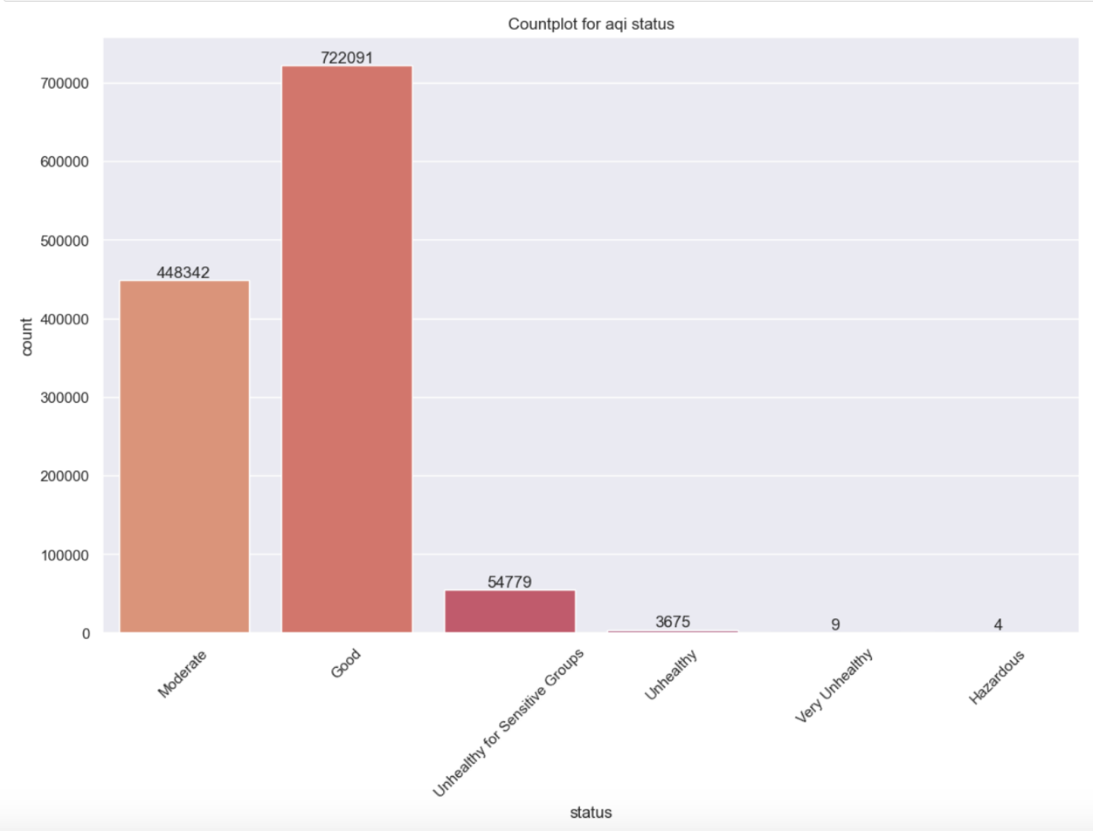

Figure : Countplot for AQI status

From the above Seaborn countplot it is shown that most of the data points correspond to good aqi values.

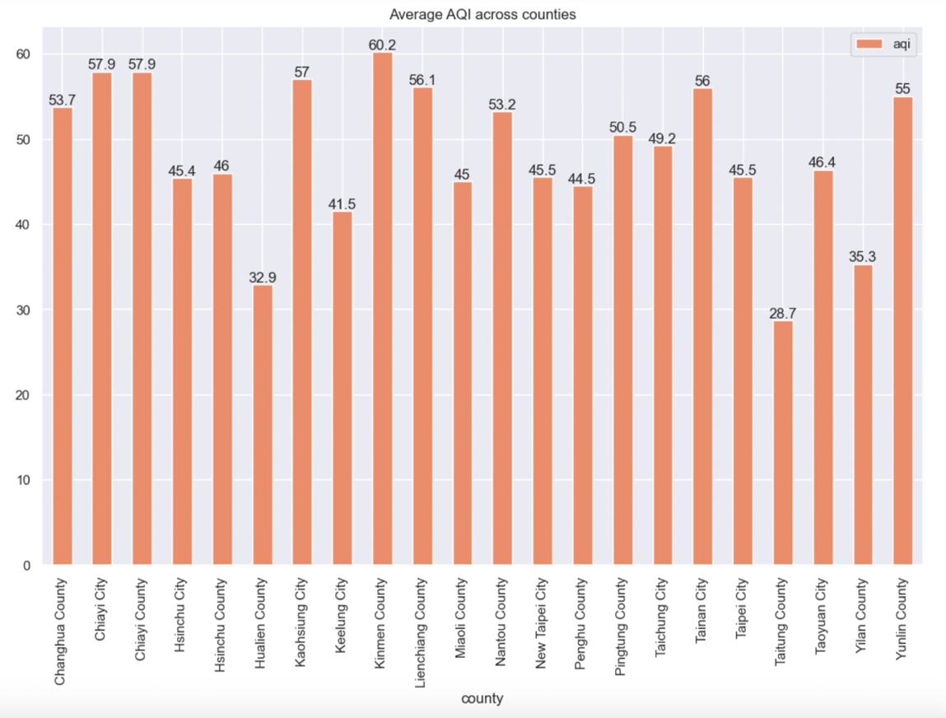

Figure :Average AQI value across all counties in 2023-2024

From the previous chart we can see that Kinmen County has the worst average aqi value for the period from Jan2023-Aug2024 and Taitung County has the best average

aqi value during the same time period.

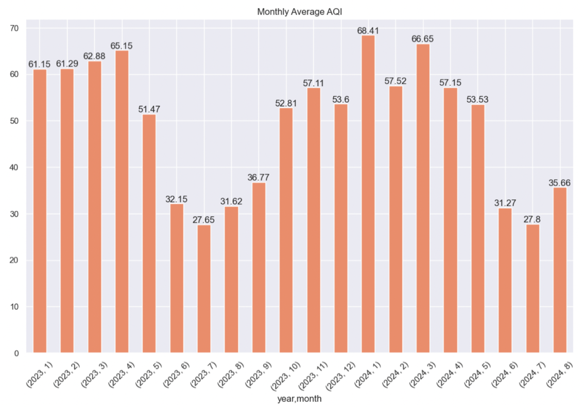

Figure :Average AQI values for each month in the year 2023-2024

From the above bar chart, it is evident that during the month of July the air quality seems to be at its best. In the year 2024 the worst level of AQI was seen during the month of January.

* 1. Complexity of Data

Taiwan’s air quality monitoring network likely collects data from multiple sources, including:

* Fixed Monitoring Stations: Official government air quality stations (e.g., Taiwan Environmental Protection Administration’s (EPA) stations) generate large volumes of data.
* Mobile Sensors: The use of IoT devices and mobile sensors in personal air monitoring or by vehicles (e.g., taxis, buses) adds another layer of data complexity.
* Satellite Data: Remote sensing data can provide broader views of air quality at the regional or national level.
* Crowdsourced Data: Data from social media, environmental apps, and citizen science projects may also be integrated into the system, providing more granular data but often with varying degrees of accuracy.

Handling large-scale data requires high computational power, storage solutions, and advanced processing techniques, such as distributed computing, cloud platforms, and big data frameworks. Since we are not using these technologies in this project we will be taking a subset of the whole data.

### 3.4 Data cleaning

* Handling Missing Data: Several columns in the dataset contain missing or null values which includes unit, pollutant majorly.
* Outlier Detection: Identified outliers using Boxplot for pollutants such as PM2.5 and PM10. In cases where values were excessively high or low (and outside a reasonable range), flagged those rows for further investigation.
* **Remove Duplicates**: Duplicated entries are removed to avoid inconsistency in data.

3.5 Data Transformation

* Date and Time Formatting: The dataset contained a timestamp column, which was in string format. Convert it to a datetime format for further analysis.
* Convert float64 to float32: Convert columns with float64 datatype to float 32 datatype to reduce the memory usage.

4.Design

4.1 Analytical methods and Technology used

In the context of this project, **regression model** is used to predict the Air Quality Index based on various air pollutants (e.g., **PM2.5, PM10, NO₂, O₃, CO, SO₂**) as input variables.

Random Forest Regressor is used to predict AQI using meteorological data and pollutant measurements.

Random Forest Regression is an ensemble learning method that combines multiple decision trees to improve prediction accuracy and prevent overfitting. It is highly effective for capturing complex, nonlinear relationships and interactions between features.

1. Programming and Data Science Frameworks

* Python: The most commonly used programming language for machine learning in environmental science due to its flexibility and availability of powerful libraries.
  + Scikit-learn: A machine learning library in Python that provides efficient tools for regression, classification, and clustering.
  + Matplotlib: Python plotting library used to create static, interactive, and animated visualizations
  + Seaborn: Python data visualization library built on top of Matplotlib that provides a high-level interface for creating attractive and informative statistical graphics
  + Pandas: Python library for data manipulation and analysis, offering data structures like DataFrame and Series to efficiently handle and analyze structured data.
  + Numpy: Python library for numerical computing, providing support for large, multi-dimensional arrays and matrices, along with a wide range of mathematical functions

2. Data Visualization and Reporting Tools

* Tableau: These visualization tools help present data and predictions in an easily understandable format.

4.2 Descriptive Statistical Analysis

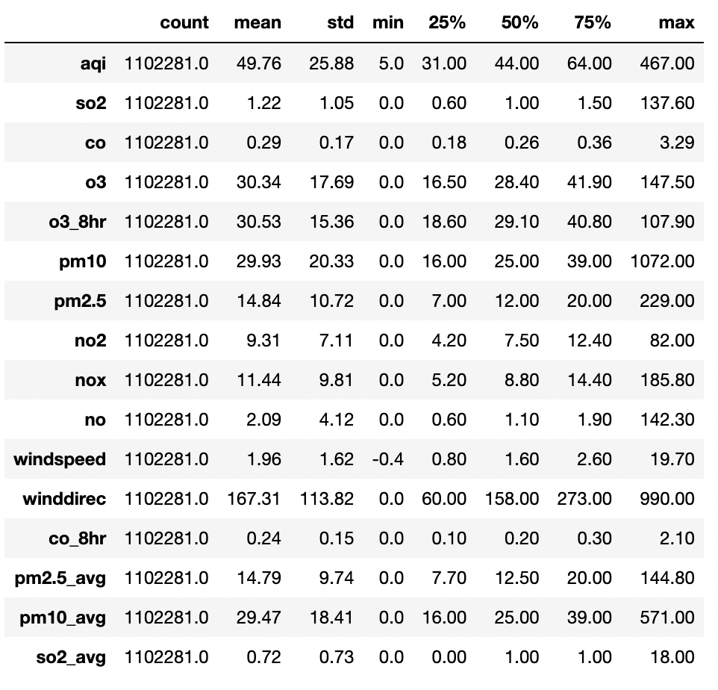

Figure : Descriptive statistics of the data

* AQI values range from 5 to 467, with a mean of 49.76, indicating that most the data contains good AQI as compared to Hazardous AQI values. The median is 44 showing that there is slight skew towards better air quality.
* so2 ranges from 0.0 to 137, with 75% of the data below the value of 1.5 which indicates lesser concentrates of so2 in the atmosphere most of the time.
* co concentrates range from 0.0 to 3.29 indicating lesser impact on the AQI values with a mean of 0.29.
* o3 ranges from 0.0 to 147.0 with 75% of the data having value lesser than or equal to 41.90
* pm10 ranges from 0.0 to 1072.0 with 75% of the data below 39.0 indicating lesser concentrates of pm10 in that atmosphere most of the time. But the max value indicates unusual presence of pm10 values at times in atmosphere.
* pm2.5 ranges from 0.0 to 229.0 with 75% of the data below 20.0 indicating lesser concentrates of pm10 in that atmosphere most of the time.
* no2 concentrates ranges from 0.0 to 82.0 with a mean of 9.31, indicating good value most of the time.
* nox concentrates ranges from 0.0 to 185.0 with a mean of 11.44, indicating good value most of the time.
* no concentrates ranges from 0.0 to 142.30 with a mean of 2.09, indicating good value most of the time.
* winddirec has max value as 999.00 which is not possible as winddirec is measured in degrees from 0 to 359 degrees.
* There are negative values in column windspeed , it might be due to instrument calibrations. Will not be taking any action for this.

Histogram for numerical columns:

From the below histograms it can be concluded that so2, co, o3, o3_8hr, pm10, pm2.5, no2, nox, no, pm2.5_avg, pm10_avg are positively skewed indicating some extreme values towards right.

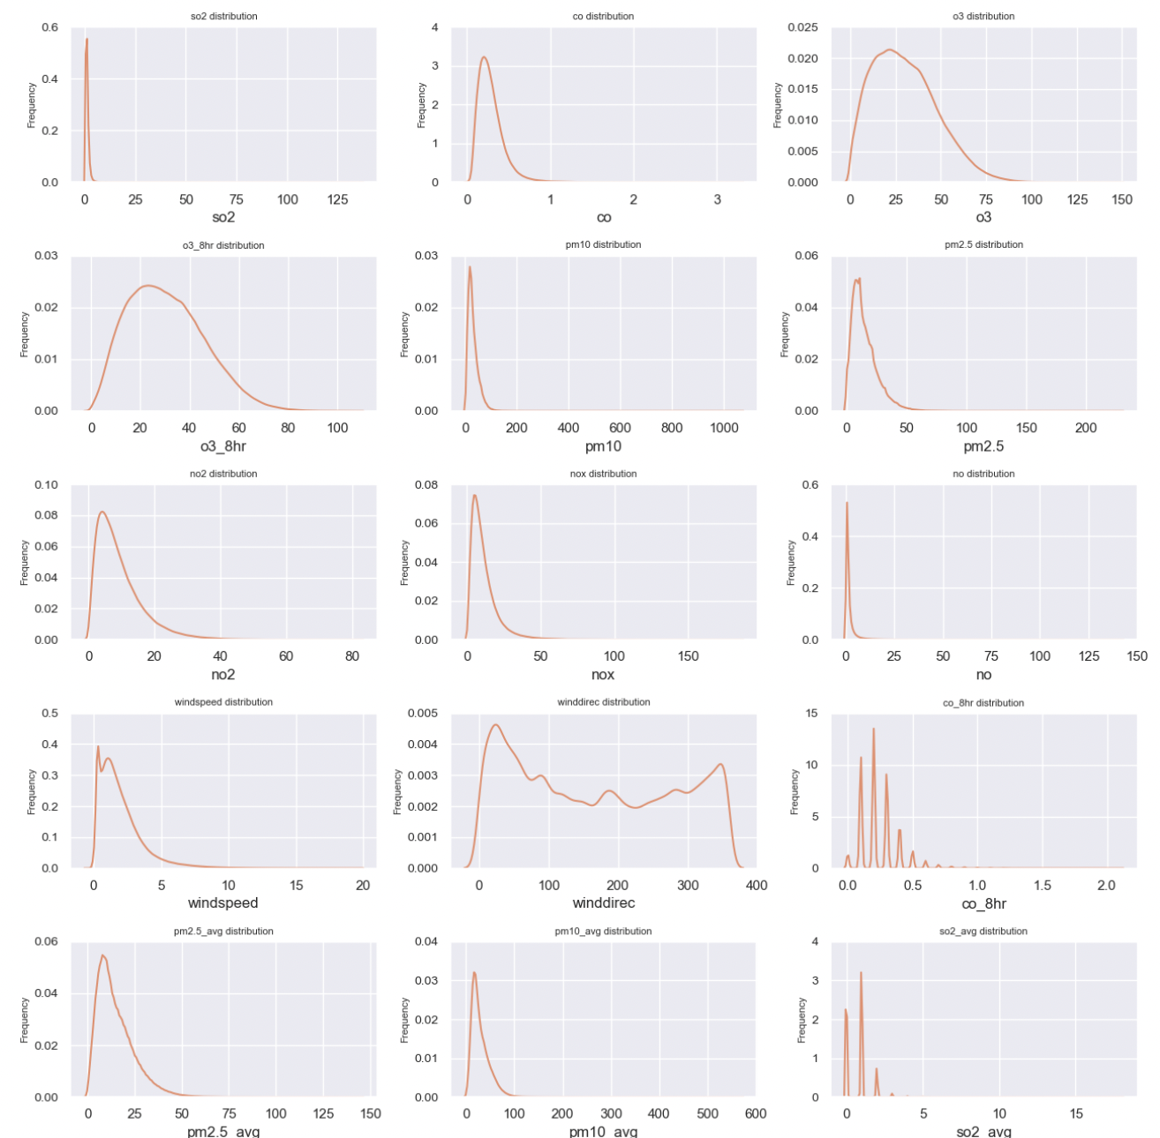

Figure : Histogram plot for Independent variables

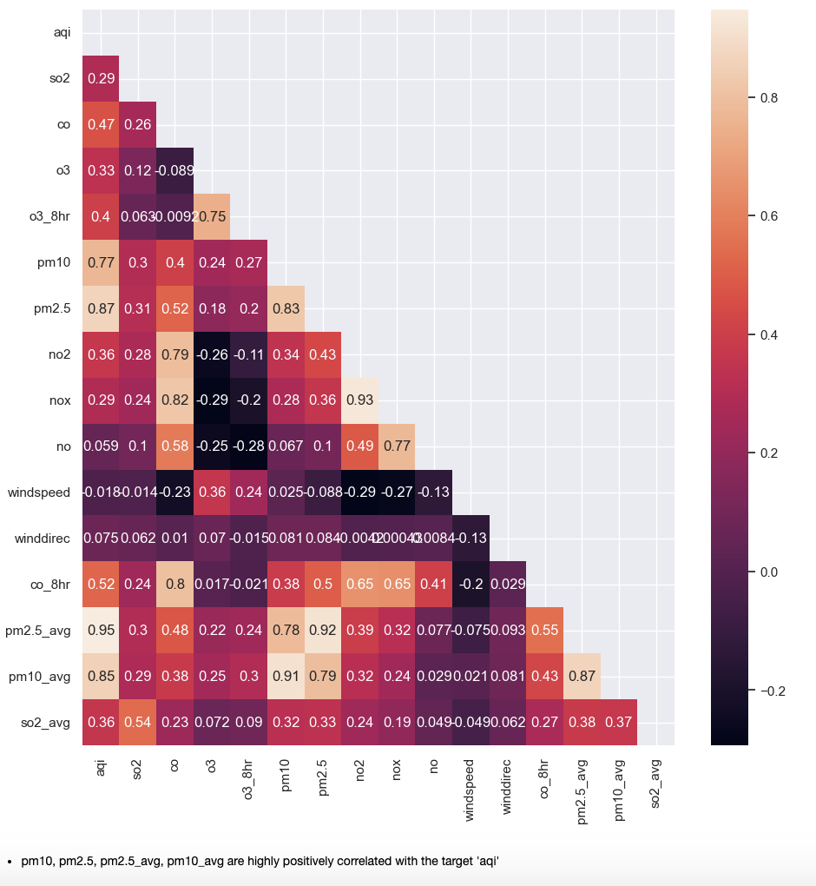

Figure : Heatmap correlations between Independent and target variable

4.3 Data Visualization

For this project, Tableau was used to create dynamic and interactive visualizations that effectively represent Taiwan's Air Quality Index (AQI) and its associated pollutants. The primary goal of these visualizations is to provide clear insights into air quality trends, regional pollution hotspots, and the impact of seasons on AQI levels. Here are few snapshots of the visuals created using Tableau.

Below is the Monthly average AQI line graph. From the Line chart visualization , it is evident that the aqi levels are good during the month of July during a year. And during the month of January in the year 2024 it recorded the worst levels of aqi. This indicates that the aqi levels are worst generally during winter season than during summer. This might be due to heating and industrial activities during the winter months.

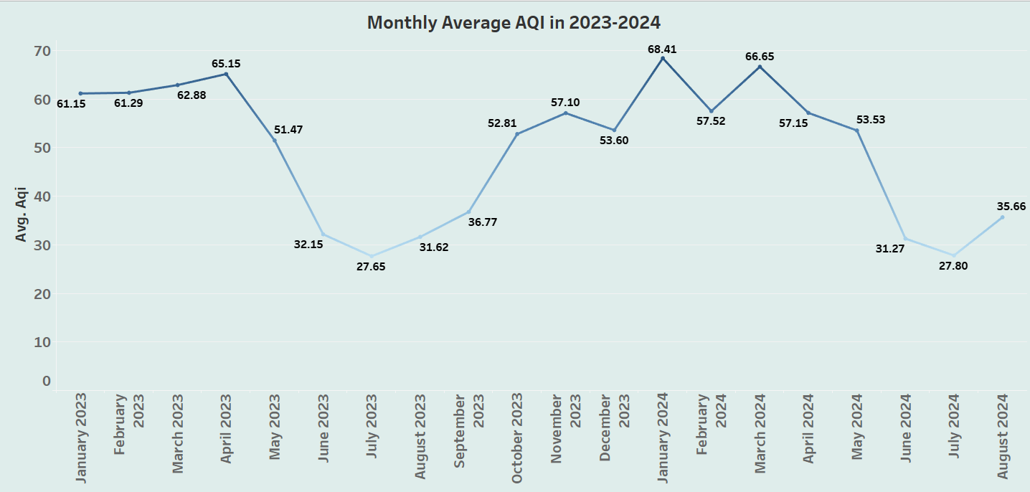

Figure :Monthly Average AQI over 2023-2024

Geospatial Distribution of AQI across various Counties in Taiwan in the year 2024 was generated using Tableau. From the Geospatial map shown next it is evident that Taitung County has the best aqi whereas Kinmen County has the worst aqi over the period from January 2024 to August 2024

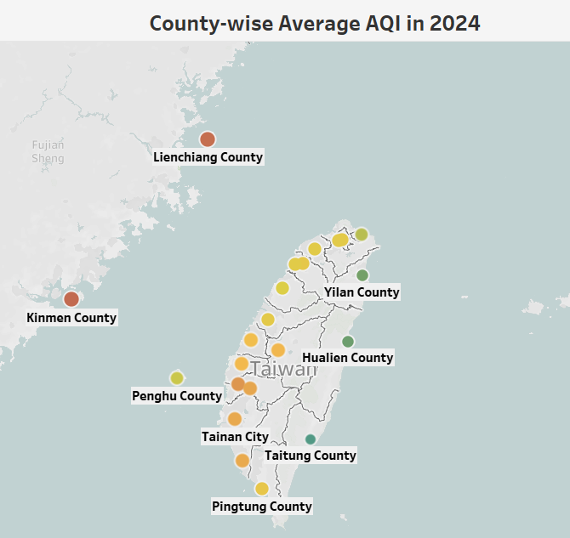

Figure :Geospatial map of Taiwan indicating average AQI values in 2024 for various counties

The below visualization shows the concentration levels of various pollutants like pm2.4, pm10, so2, no2,co, o3.

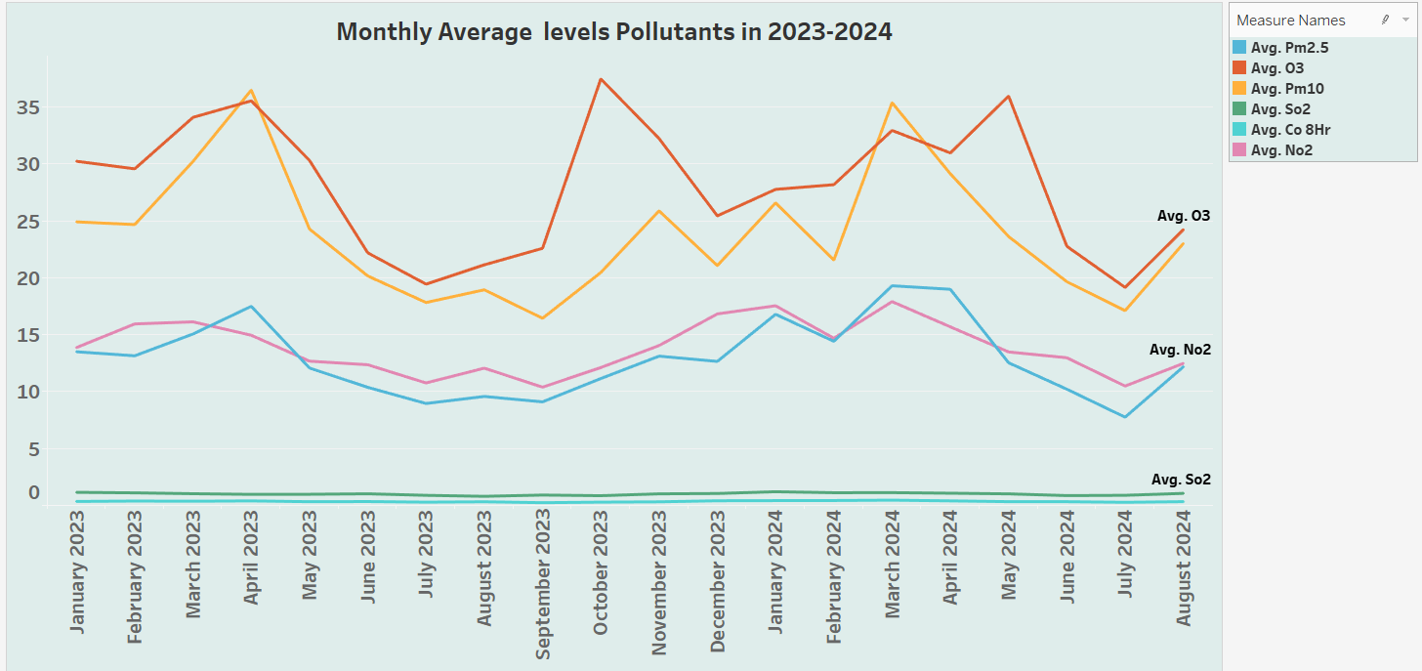

Figure :Monthly average values for various pollutants

4.4 Feature Engineering

With respect to model building certain columns which are irrelevant, redundant, or highly missing features are dropped. The column ‘unit’ is dropped as it is a column with highly missing values. The column ‘pollutant’ is dropped as it can lead to data leakage towards the target ‘aqi’, it is NaN for rows where the aqi values are good. The columns

‘sitename’, ‘siteid’, ‘unit’, ‘latitude’, ‘longitude’ are dropped as they are irrelevant for the model building and prediction.

After initial model building using RandomForestRegressor, it was found that independent variable pm2.5 was contributing 90% to the target prediction, hence leading to a potential data leakage towards the target. So this independent variable ‘pm2.5_avg’ was removed.

Further building the model with independent variables which were removed as mentioned above, there were features which were contributing less than 2% towards target ‘aqi’ prediction. So these independent variables 'o3', 'so2_avg', 'so2', 'no2', 'nox', 'no', ‘windspeed', 'winddirec' which were not contributing to the target ‘aqi’ prediction were dropped.

4.5 Short data snapshots

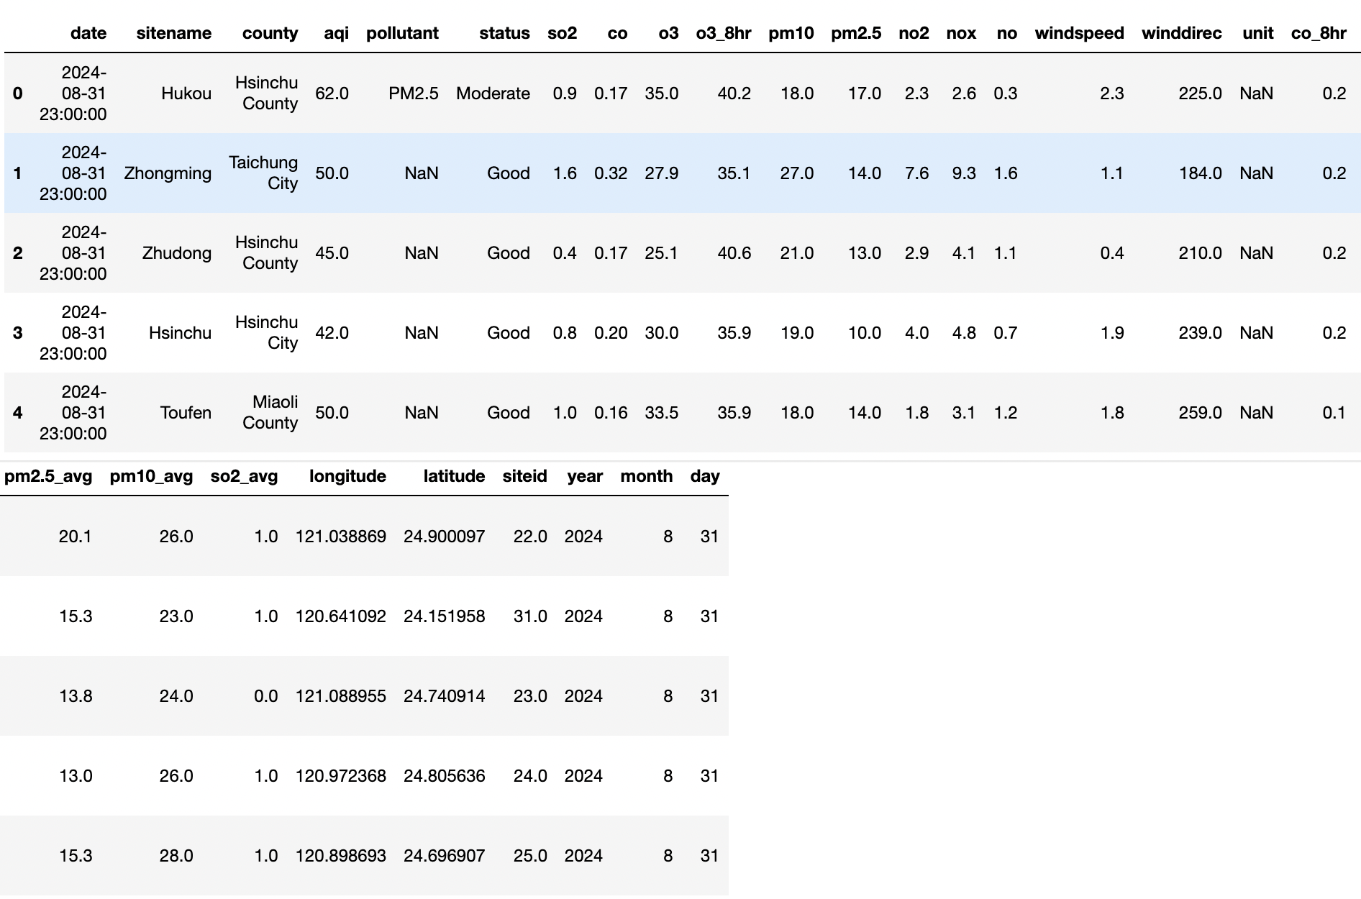

Figure :Snapshot of data

* 1. Short code snippets

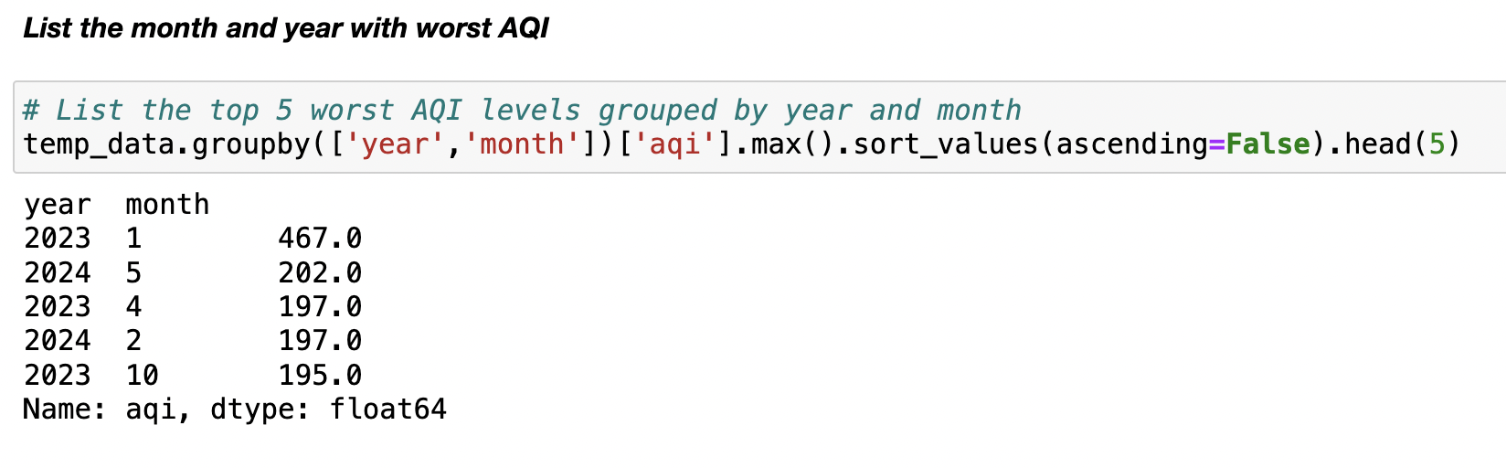

Figure : Short code snippet-1

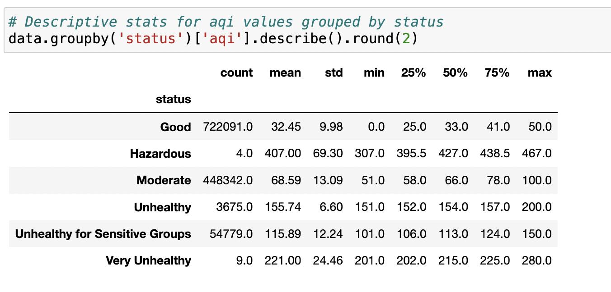

Figure :Short code snippet-2

5.Modelling

5.1 Selection of model/technique

To Begin with models like Linear Regression or Decision Trees were implemented for simplicity and interpretability. But as Linear Regression has few assumptions which were not met with this dataset, tree-based model was used.

When we compare between Decision tree Regressor and Random Forest Regressor, Random forest Regressor can handle large dataset and are robust to overfitting whereas Decision Tree Regressor is prone to overfitting. Also, Ensemble Model like Random Forest Regressor can help in improving the performance of the model and also provides feature importance data. Using oob_score in Random forest we can make sure that the model predicts on unseen data. The **OOB score** is an unbiased estimate of the generalization error, which can help assess the model's performance without relying on cross-validation or a separate test set. Random forest was chosen due to the following advantages:

Accuracy: Random Forest generally provides high predictive accuracy by averaging out predictions from multiple trees.

Robustness: It’s less sensitive to noise and overfitting than a single decision tree.

FeatureSelection: Random Forest can automatically assess the importance of different features and highlight which pollutants or factors have the greatest impact on AQI.

Interpretability: While Random Forests are less interpretable than simpler models (like linear regression), they still provide feature importance metrics, which can give insights into the driving factors of air pollution.

* 1. Challenges faced

Identifying relevant features from raw environmental data like air pollutants, was challenging. It required domain knowledge to understand how these features interact and affect the AQI.

Many features were are highly correlated, leading to **multicollinearity**, which could affect model stability and performance.

As environmental data often involves complex relationships, explaining model predictions in an interpretable way is crucial, especially for decision-making in environmental management.

Striking the right balance between model complexity and generalization was difficult. We used cross-validation to tune hyperparameters and ensure better generalization

Tuning the hyperparameters for complex models like **Random Forest** was time-consuming and computationally expensive, especially with this large dataset

* 1. Evaluation and Cross Validation

Below listed Metrics are used for evaluation:

* **Root Mean Squared Error (RMSE)**: This is the square root of the MSE, which provides the error in the original unit of the target variable, making it more interpretable.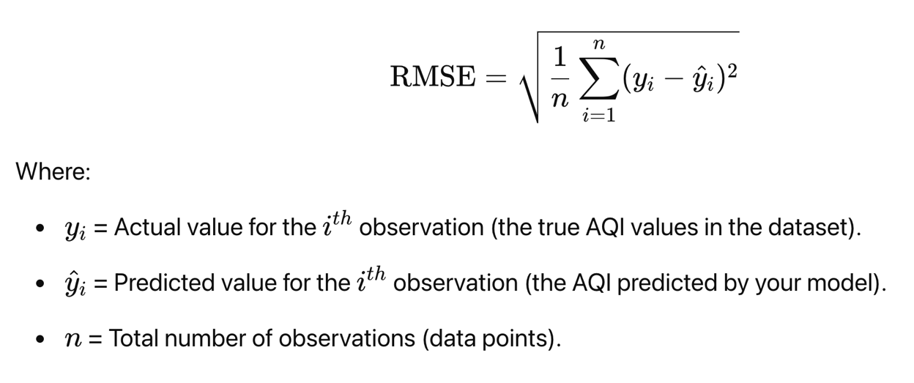
* **R-squared (**R^2**)**: Measures the proportion of variance in the target variable that is explained by the model.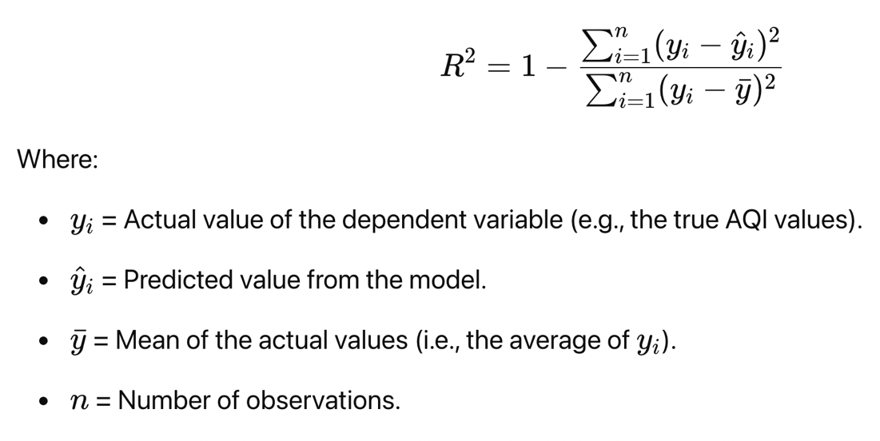

**RandomizedSearchCV** is used to tune hyperparameters for the Random Forest Regressor which will help in improving model performance. RandomizedSearchCV is implemented with 5-fold cross validation and parameters n_estimators, max_depth, max_features, max_leaf_nodes were used as part of hyperparameter tuning.

**n_estimators**: Number of trees in the forest. More trees generally improve performance but increase computation time.

**max_depth**: The maximum depth of each tree. Deeper trees can capture more complex relationships, but they can also overfit. The **best max_depth** found by the search will tell you the depth that best balances model complexity and generalization.

**max_features**: The number of features to consider when looking for the best split. Typically, sqrt is used, but **RandomizedSearchCV** may suggest other values depending on the dataset.

max_leaf_nodes: The number of leaf nodes in each tree, this helps in controlling the tree’s depth and complexity.

RandomizedSearchCV was done with RandomForestRegressor as base estimator with above listed parameters. And this RandomizedSearchCV provided the below listed best parameters for RandomForestRegressor

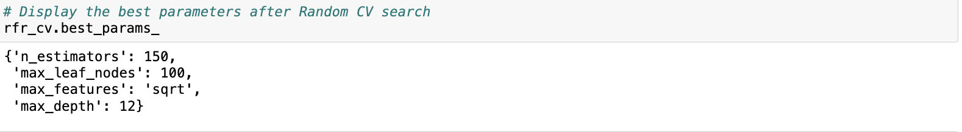

Figure :Hyperparameters used for RandomForestRegressor

The RandomForestRegressor model with parameters listed above gave the below listed metrics for training and test data

The Train data has an R^2 value of 0.918, means 91.8% of the target ‘aqi’ can be explained by the independent variables used for building the model and RMSE value of 7.40, shows that while predicting the aqi value there is an average error of 7.40 units.

The Test data has an R^2 value of 0.918, means 91.8% of the target ‘aqi’ can be explained by the independent variables used for building the model and RMSE value of 7.39, shows that while predicting the aqi value there is an average error of 7.39 units.

* 1. Model Interpretation

**Best Hyperparameters** and **Model Performance** were discussed in the previous section.

Feature Importance helps to identify which features (e.g., PM2.5, wind speed) are most influential in predicting AQI.

The following figure shows the Feature Importance of the independent variables contributing to target ‘aqi’. The feature pm10_avg contributes to 37.72% of predicting ‘aqi’ value, followed by pm2.5 which contributes to 33.3%, pm10 contributes to 13.41%, followed by o3_8hr with 7.76% and co_8hr with 5.12% and co corresponds to 2.65% contribution towards target variable ‘aqi’.

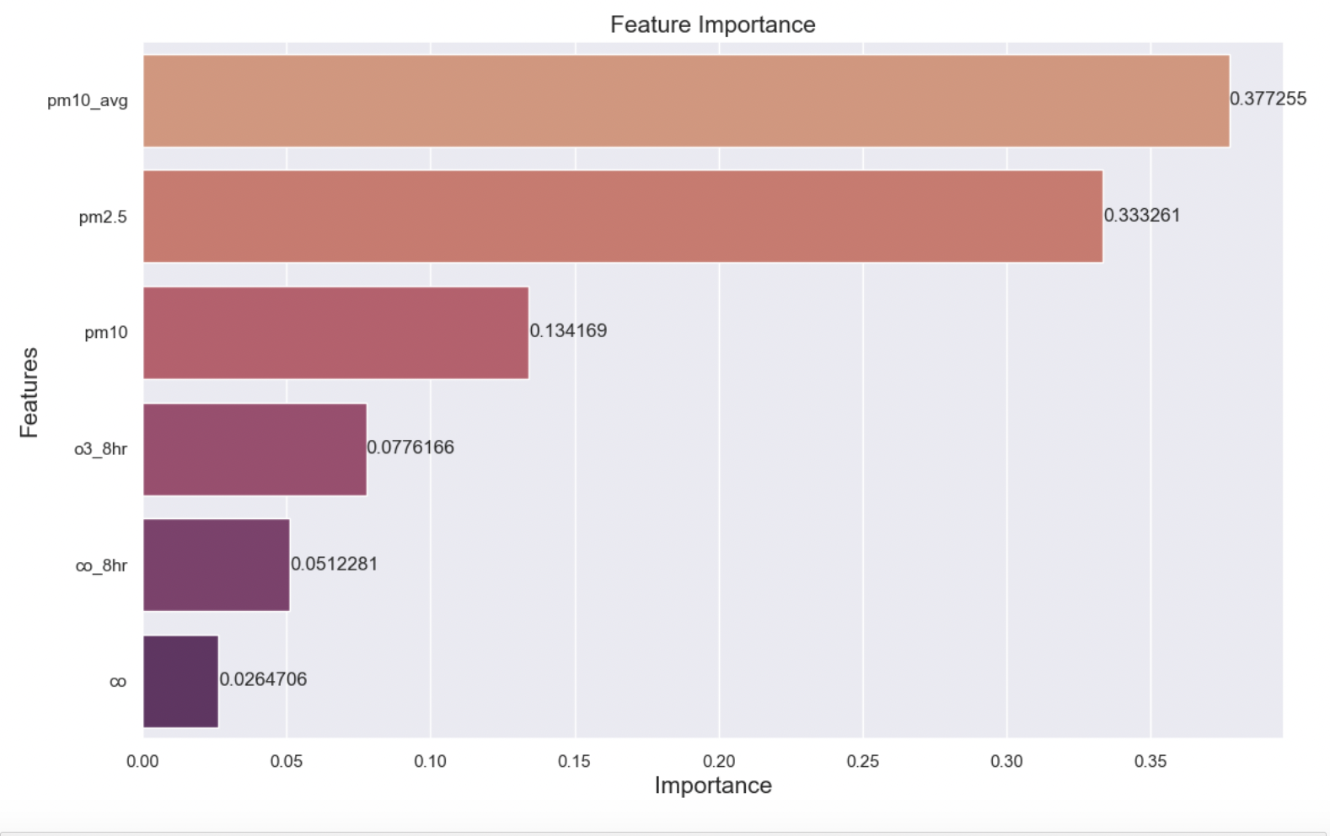

Figure :Bar chart indicating Feature Importance

* 1. What worked/What didn’t work

The Random Forest algorithm performed well due to its ability to capture non-linear relationships in the data and handle interactions between features. The ensemble approach helped in reducing overfitting and improved generalization. Implementing **Random Search CV** for hyperparameter tuning allowed for improved model performance by optimizing the hyperparameters

Although ensemble methods like **Random Forest** are less prone to overfitting, there were instances where models showed **overfitting** on smaller training datasets. This occurred when hyperparameters weren’t optimized carefully, leading to models that performed well but which were less interpretable. Some features (like so2_avg, o3, nox, no2, no, **wind direction**, **wind speed**) had little predictive value, leading to **irrelevant features** being excluded in the model. This was done to increase the model interpretability.

* 1. Short data output/snapshots

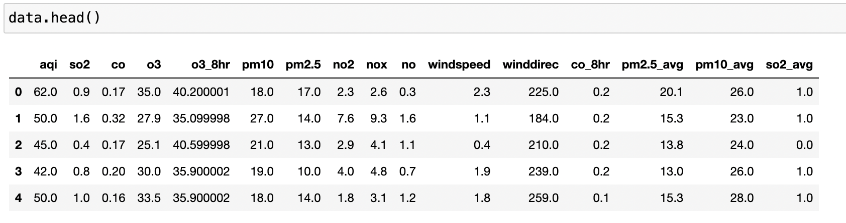

Figure :Short data output

* 1. Short code snippets

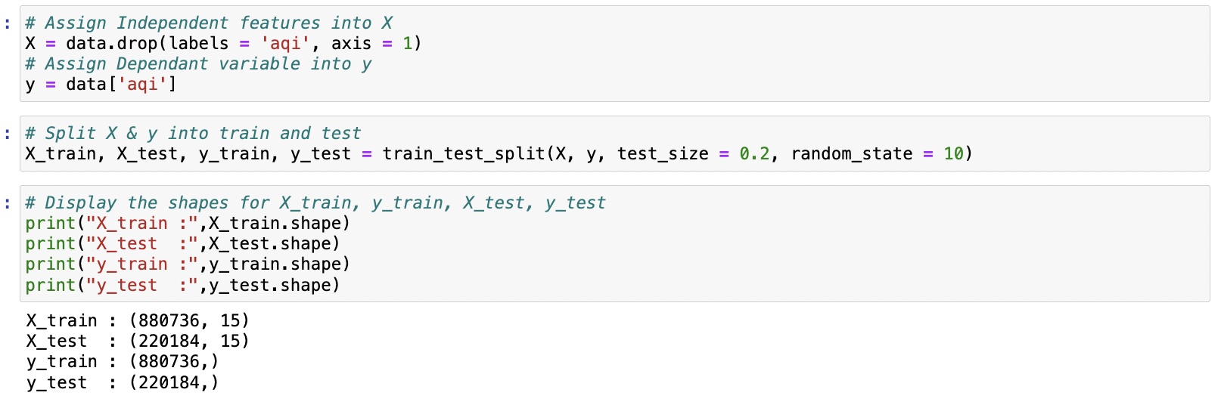

Figure : Short code snippet -1

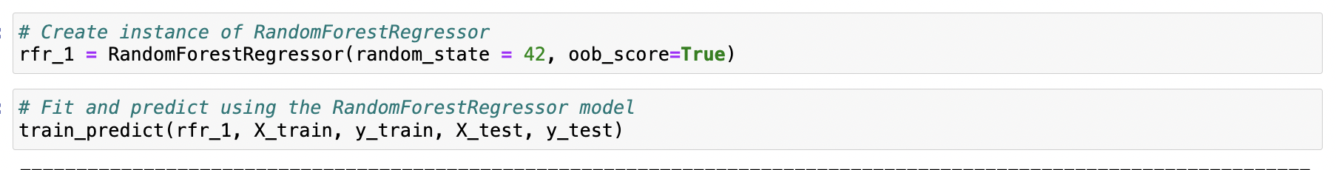

Figure : Short code snippet -2

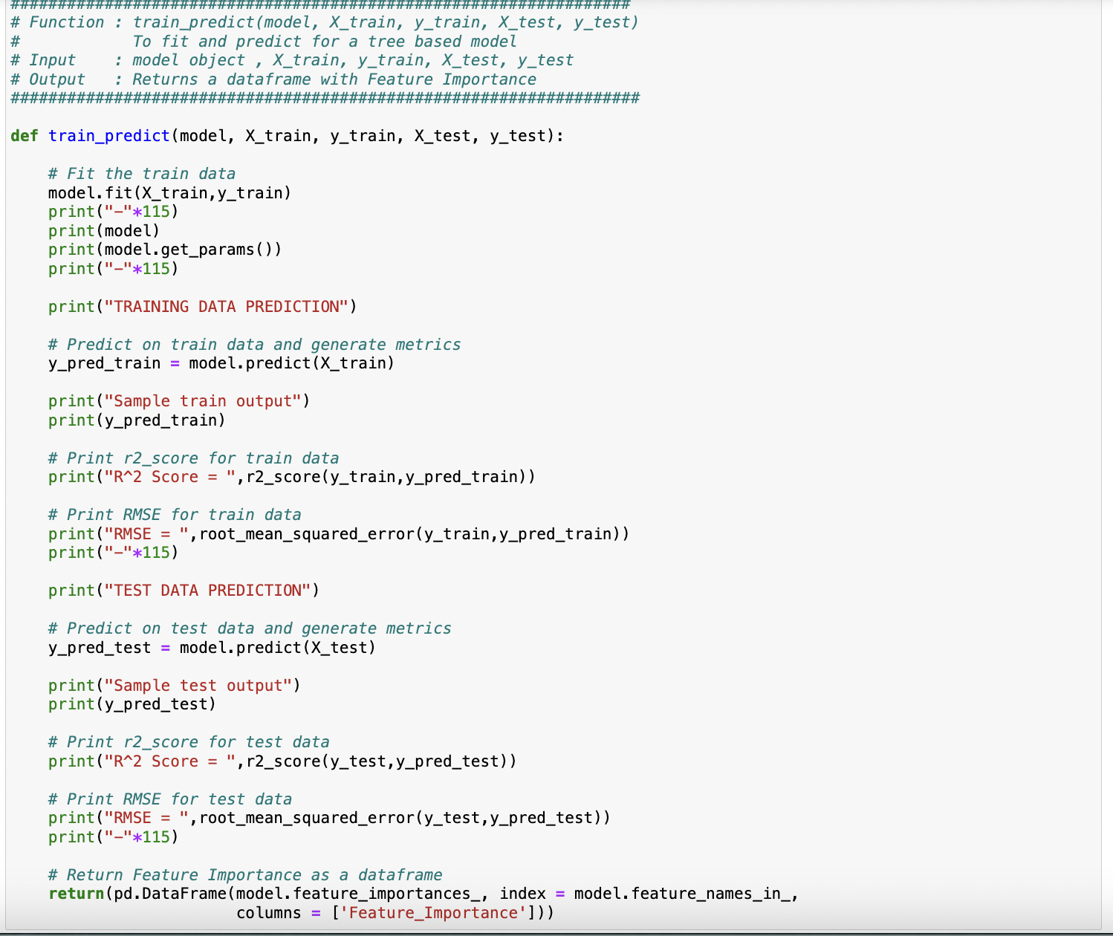

Figure :Short Code snippet -3

6.Key Results

* 1. Output of intermediate steps

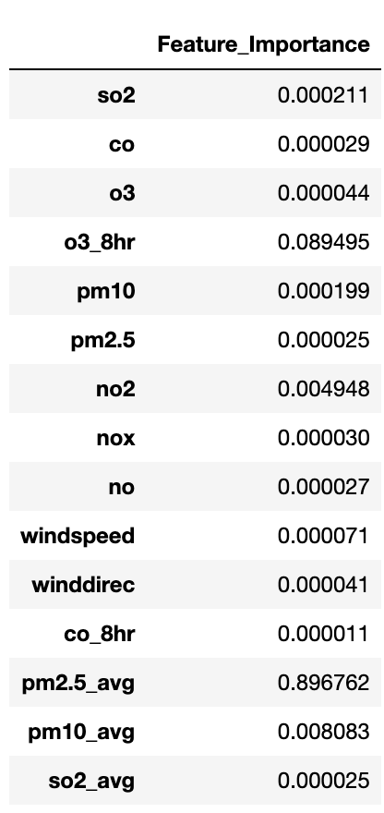

Figure : Output of intermediate steps

The snapshot figure shows the results of first iteration of the model building using RandomForestRegressor. We can see from the intermediate output that pm2.5_avg contributes to nearly 90% towards predicting aqi leading to a possible data leakage.

6.2 Final outcome/Sample outputs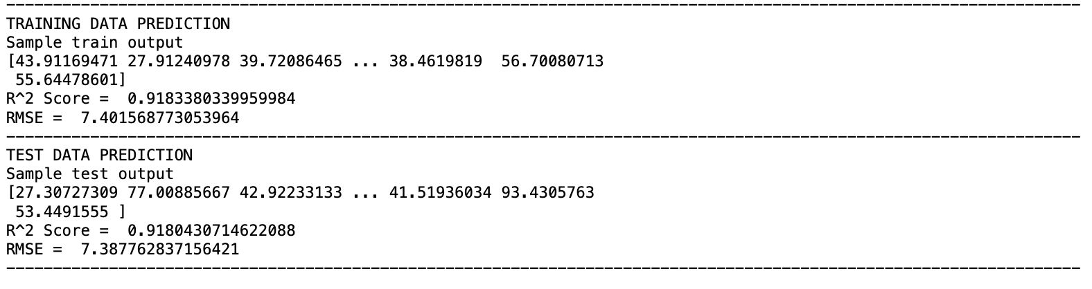

Figure : Final Output

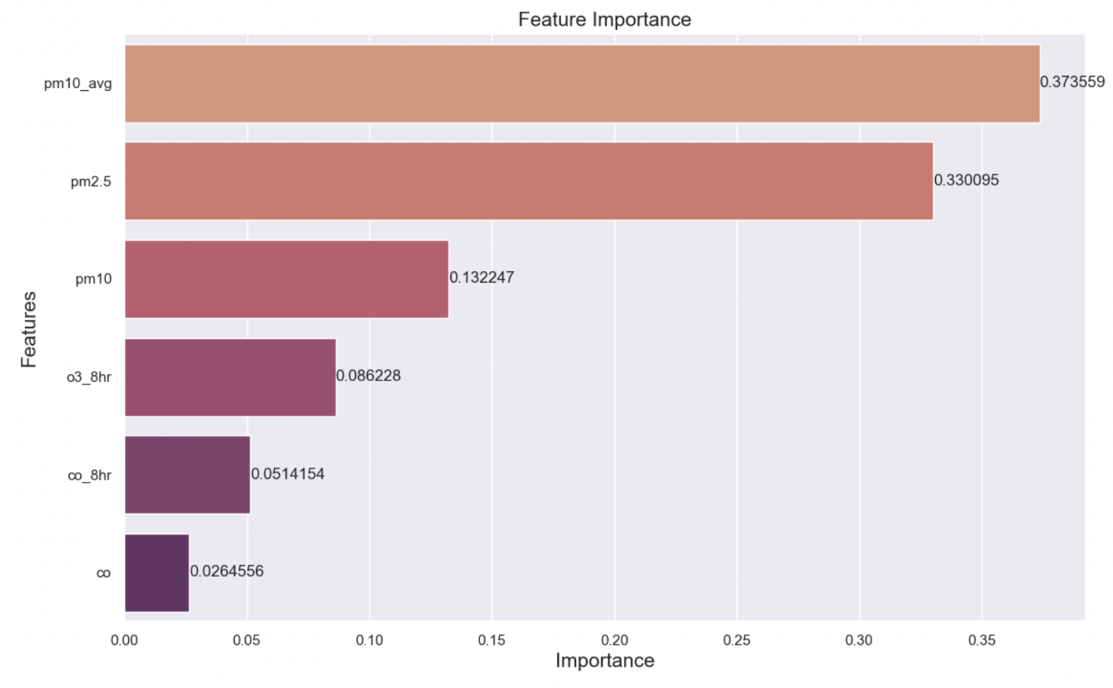

Figure :Final Feature Importance list

* 1. Analysis of the results

Considering the r-squared value and RMSE values, the model is generalizing well with unseen data. The r-squared value for train and test data are 0.918 and 0.918 respectively. The RMSE values for train and test are 7.40 and 7.39 respectively. The model is generalising well with respect to unseen data.

7.Conclusion

* 1. Summary of the project outcome

The project focused on predicting the Air Quality Index (AQI) for Taiwan using machine learning models. After preprocessing the data through feature engineering techniques such as handling missing values, we trained model using **RandomForestRegressor** to predict AQI levels. The model's performance was evaluated using metrics like **RMSE**, **R-squared**, and **Cross-Validation**, with results indicating a strong predictive capability. Feature importance analysis revealed key environmental factors contributing to AQI variations. The model performed well, demonstrating the potential for real-time AQI prediction and improved air quality management strategies.

* 1. Future work

The future work for the Taiwan Air Quality Index project is focused on enhancing the model's accuracy, robustness, and real-world applicability. By incorporating real-time data, advanced machine learning techniques, and spatiotemporal modelling, the project can better address the complex dynamics of air quality. The model provides real-time AQI predictions but does not offer forecasting capabilities for future pollution levels over extended timeframes (e.g., days or weeks).Extend the model to predict AQI in the coming days or weeks. This can be done using **time-series forecasting.**

8.References

Dataset Source:

https://www.kaggle.com/datasets/taweilo/taiwan-air-quality-data-20162024